1.WAP to traverse or iterate ArrayList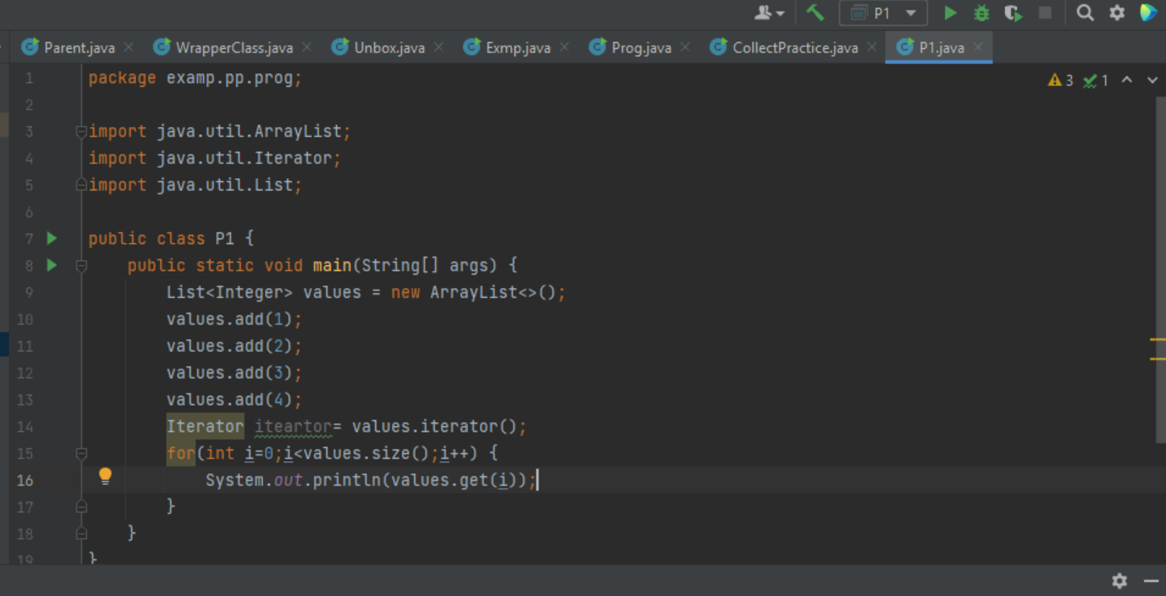

OUTPUT:

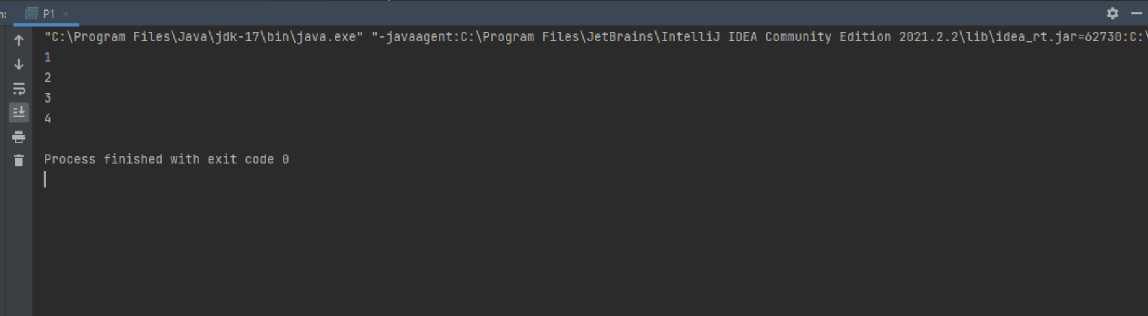

2. WAP to convert list to array

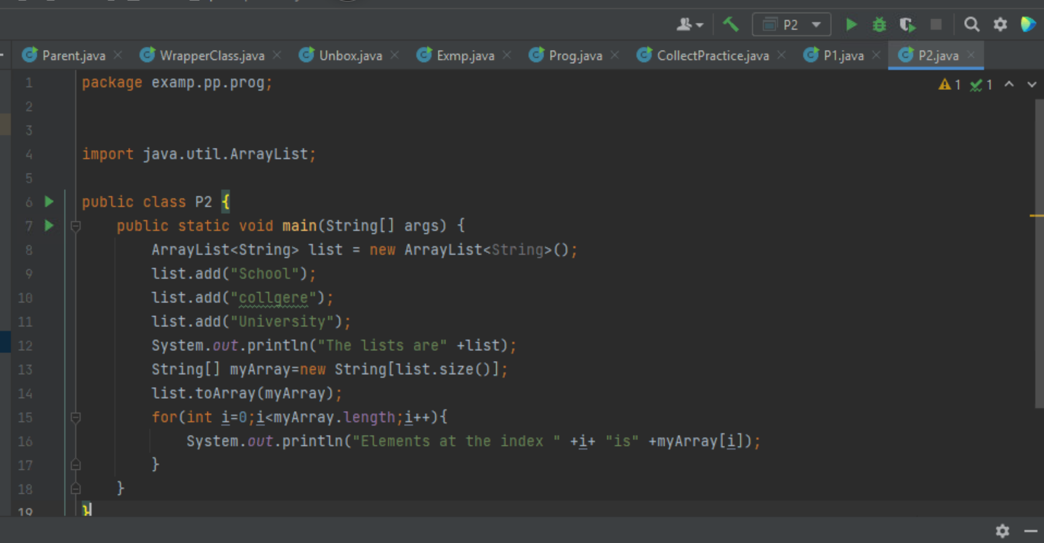

OUTPUT:

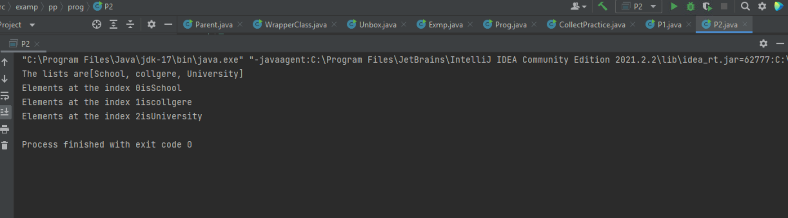

3.WAP to check if element exists in ArrayList

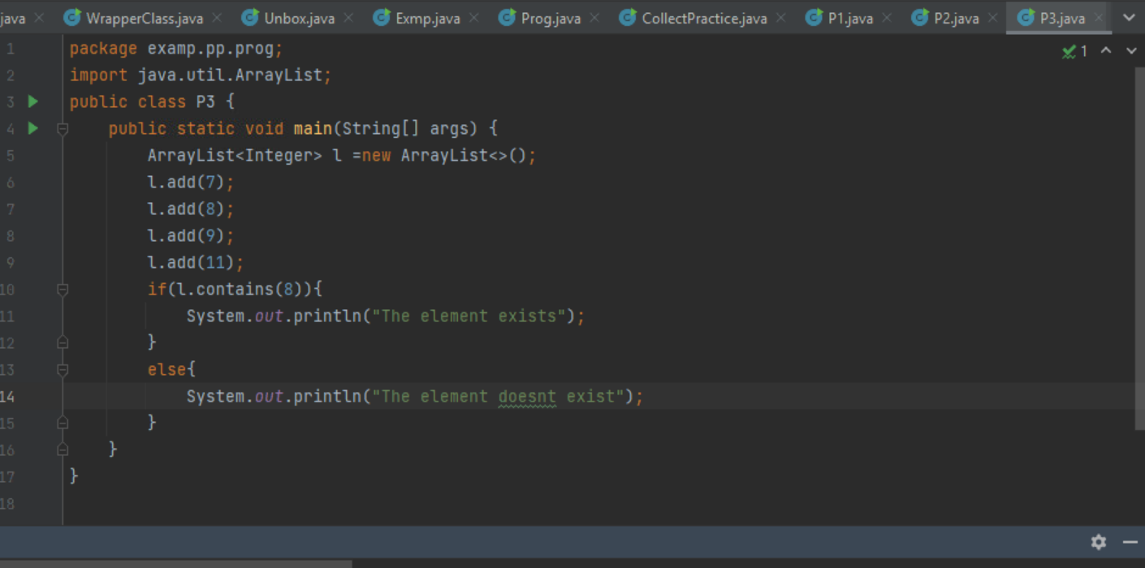

OUTPUT:

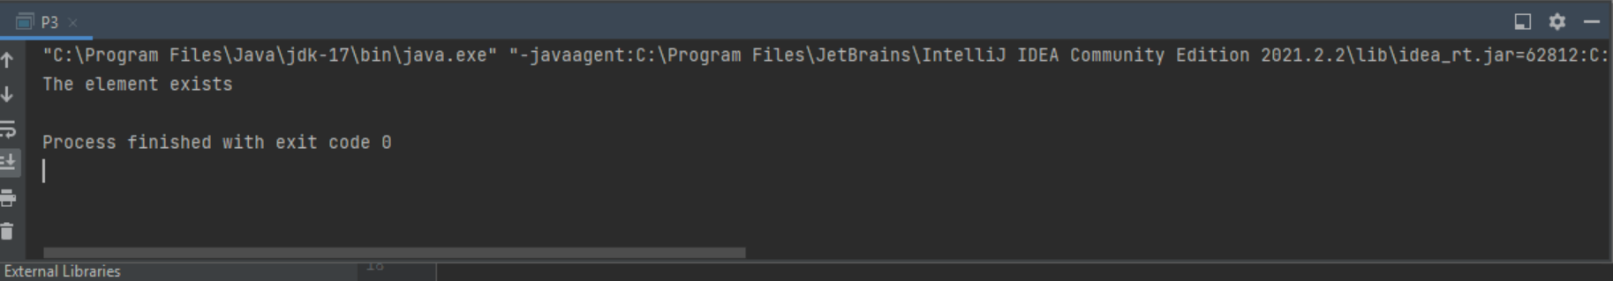

4.WAP to check if element present in HashSet

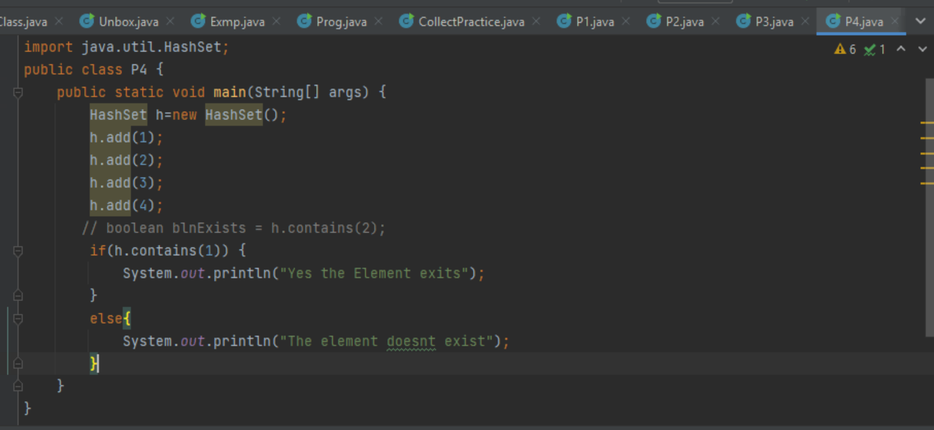

OUTPUT:

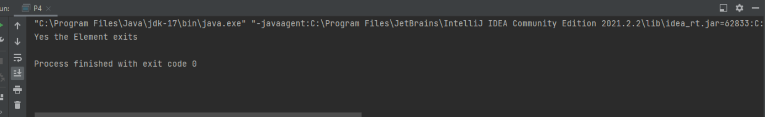

5. TO find the length of ArrayList

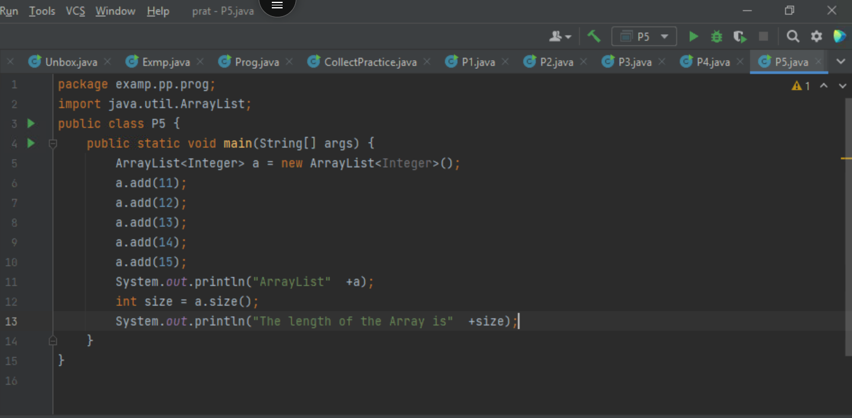

OUTPUT:

